Box 42 Newsletter - May 2020
 Supporting the fire community since 1942
Meetings. There was no meeting in April because of the Stay Home-Stay Safe order. This would have been our 78th anniversary observation of the formation of Box 42. It's always nice to return to our roots at Engine 42. Maybe next year.
There is not likely to be a meeting in May, and Anthony Rzucidlo of the Meeting Committee has announced that the annual photo tour has been rescheduled for July 11. We'll have more information in the coming months.
DFD apparatus news. Deputy Commissioner Dave Fornell sends along this update:
The new chief's vehicles, 2020 Ford Utility Interceptors, are arriving.
EMS supervisors 1104 and 1105 were issued hybrid models.
Chief 9 received the first gas model.

There are 4 more to be issued, two hybrid models will be Chief 4 and Chief 8, one gas model will be 1106 and the remaining two will be issued to battalion chiefs after the fleet is evaluated.

The hybrid models are being tested by the fire and police departments to determine if we will purchase more in the future. Nine more gas models are on order and should be received during the summer.
Also from DC Fornell. Had a little fire yesterday on the East Side. Vacant building with wind gusting up to 50-MPH. Attic was tough to make and front porch collapsed. Chief 1 used six engines, one truck, one squad and a medic. All went to work. At the same time, another medic responded on Gratiot a few blocks away for a "person who tried to set fire to himself." Victim was burned and transported. I wonder how that happened?

Take care and stay safe.
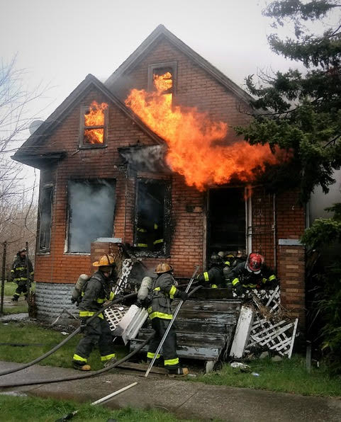

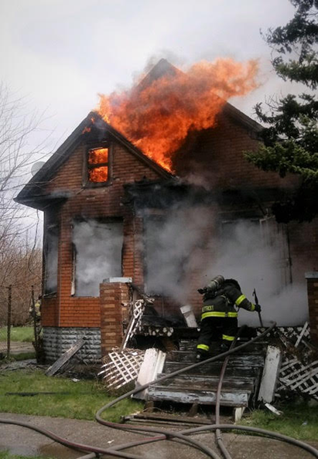

Covid 19 and the DFD.
*From WDIV: https://www.facebook.com/shawn.ley.5/videos/2705023169608552/
*From DFD Legacy: Skylar Herbert, the 5 year old daughter of one of our Detroit Firefighters has died from Covid 19 complications.
Please hold the Herbert family and our fire family up during this horrible time.
Skylar's Father, Ebbie, is a Detroit Firefighter and her mother, LaVondria Herbert, a Detroit police officer.

New Trial ordered in Walter Harris's death. From the Detroit News, April 20th.
Detroit – A man convicted of arranging an arson that killed a Detroit firefighter has been sentenced three times since the 2008 crime.
Twelve years and two judges later, the trial court still hasn’t been able to get it right, the Michigan appeals court said.
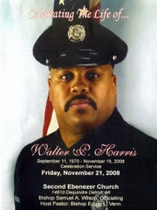
Walt Harris (Photo: Family photo)
Mario Willis was convicted of second-degree murder after being charged with paying a handyman $20 to burn down an abandoned house. The roof collapsed on firefighter Walt Harris while he was fighting the fire, killing him.
The appeals court last week acknowledged the “tragedy” but returned Willis’ case to Wayne County Judge Margaret Van Houten. The court said she had failed to adequately explain why he deserved a minimum prison sentence of 37 years. Van Houten exceeded the guidelines, which would put the minimum sentence anywhere from about 19 years to 31 years. A prisoner is eligible for parole review after the minimum sentence.
The appeals court noted that Willis, now 38, has had “exemplary behavior” behind bars.
“A defendant’s behavior in prison since his prior sentencing is a proper consideration on resentencing,” the court said.
Melvin D. Jefferson, Sr., first African American to serve as Fire Commissioner for the City of Detroit for 20 years, died peacefully in his home on Monday, April 6, 2020. He was 97.
In 1968, he was appointed to the Detroit Board of Fire Commissioners by Mayor Cavanagh and served until 1974 when he was then appointed Fire Commissioner for the City of Detroit, by Mayor Coleman A. Young.
A memorial service will be held at a later date.
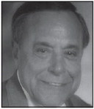
Maury Roche. We regret to inform the members of the passing of former DFD Chief of Communications Maury Roche who passed away on 4/21/20 at the age of 96. From John Kaled.
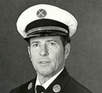
Scotty Prentice. Colm Norman Prentice of Woodhaven, passed on March 31, 2020. Colm, aka Scotty, was born March 23, 1947, in Dumbarton Scotland, of Irish ancestry. Colm joined the Detroit Fire Department, moving up to Arson, the investigative division where he often distinguished himself. Retired in 1996 he went on to do the the same work on a private basis. From George Dahl.
Closer to home. Our thoughts are with Box 42 member Russ Dalziel and long-time fire buff and friend Harve Disner who are recovering from Covid-19.

Detroit Firefighters battle a blaze on Fenkell. https://www.clickondetroit.com/news/local/2020/04/11/crews-battle-massive-fire-on-detroits-west-side/?fbclid=IwAR1YYpytvMYyrBON6eCJPz126p3x7ehWB8rMsnC5MUIOVGYTES3wIJ7APLE
Last Resort. Doug Baier, former Livonia firefighter now living on the west coast, sends this piece about the Seattle Fire Department's museum. Love that Seagrave.
http://seattlerefined.com/lifestyle/seattles-vintage-fire-trucks
Mathew Corner posted on Face Book this review of the evolution of fire apparatus of the County Fire Authority in Australia.
https://www.facebook.com/cfavic/videos/540106616910901/
A really old box list. Joe Provost found this on the DFD Legacy FB page. Date unknown.
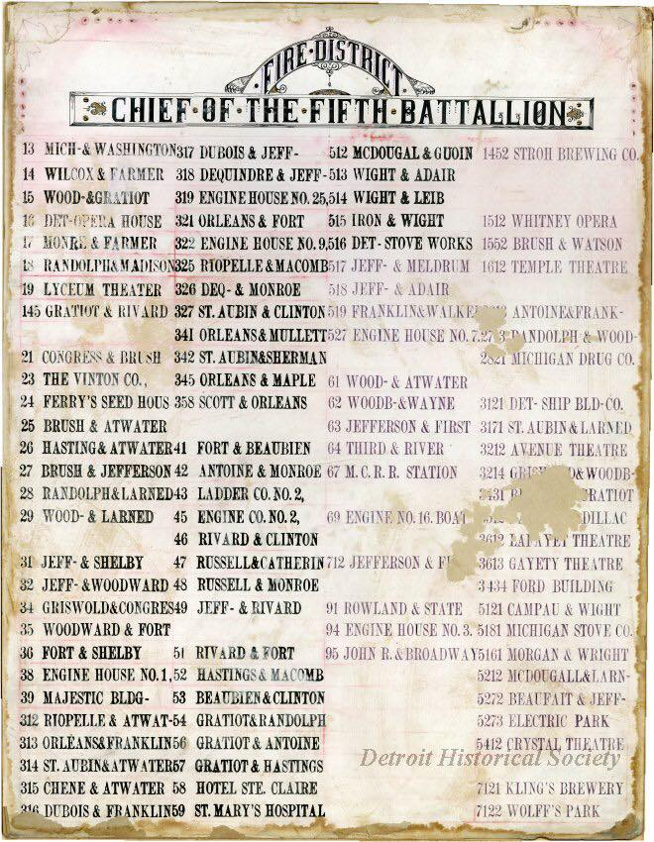
Not fire related, but this clip of the end of a Michigan State Police chase is worth a look.
https://mail.google.com/mail/u/0/#label/Box+42+input?projector=1
Bill Rosenblum, Editor
Blake Govan, President

